**Note for information**

Interim results of the evaluation of JobPath

26 November 2018

## Introduction

This note presents interim results of an econometric evaluation of the JobPath contracted public employment service.

The evaluation is being carried out as a partnership between the Directorate for Employment, Labour and Social Affairs of the Organisation for Economic Co-operation and Development (OECD) and the Statistics and Business Intelligence Unit of this Department. The final outputs of the project will be (1) the publication of a joint OECD-DEASP report, and (2) regular quarterly publication of updated outcome statistics for JobPath participants using the same methodology as in the published report.

In this evaluation, we use cluster analysis to segment the Live Register into seven groups of people with similar labour market histories, and then compare the outcomes of those who received the JobPath service earlier, later, or not at all compared to other eligible people within each cluster.

These clusters have been created for each quarter from 2014 to 2017, and detailed results for each cohort will be published in the final report.

The initial results presented here focus on those who were eligible to start JobPath in Q1 2016.

We estimate that:

* On average, yearly earnings from employment in 2017 were boosted by about €600 for people who started JobPath in Q1 2016, compared to similar eligible people who didn’t start JobPath in that quarter.
* On average, total yearly 2017 income – including both employment earnings and social welfare income – was also boosted by about €600 for people who started JobPath in Q1 2016. That’s about a 6% uplift in total income for the people who started JobPath.

## Project outputs

1. Main results presentation to DEASP Management Board or programme board, SG and Minister in December 2018
2. The evaluation report, co-authored by OECD and DEASP, will be launched on 31 January 2019
3. Regular quarterly publication of updated outcome statistics for JobPath participants using the same methodology as in the published report.
4. The evaluation framework developed in this project will be the basis of forthcoming evaluations (e.g. of the Department’s activation and case management processes and other labour market programmes)
5. A subsequent OECD paper with additional data as available, directed towards an international audience, and focusing on the specifics of JobPath and on methodology

## Policy background and operation of JobPath

Public Employment Services (PES) help equate supply and demand on the labour market, by aiding the matching process between employers and jobseekers. PES activities include *Job brokerage,* *Provision of labour market information,* *Management of labour migration,* *Jobseeker engagement*, *and employer engagement.*

In Ireland, the PES is managed by the DEASP and is delivered via two main channels; directly through the Intreo service or through contractors. JobPath, a contracted, payment-by-results employment service, provides additional resources to enable the provision of a high quality case managed employment support service to people who are long term unemployed. By augmenting and complementing the Department’s existing employment service capacity, JobPath allows more intensive engagement with the long-term unemployed and complements existing contracted services such as the Local Employment Service (LES), Jobs Clubs and EmployAbility.

Intensive engagement with the long-term unemployed requires considerable resources and case officer time. Prior to the introduction of JobPath, the ratio of clients to case officers in Ireland was around 540:1; which was considerably high by international standards, where figures of 100 – 150:1 are the norm. This reflected the financial and recruitment constraints on the public service and limited the degree to which the Department of Employment Affairs and Social Protection could expand its range of services to the target groups. The introduction of extra capacity, via JobPath, to target long-term unemployed jobseekers improved this ratio significantly to approximately 200:1 and allowed Intreo case officers to focus their time and effort on a smaller pool of unemployed jobseekers.

In December 2014, the Department of Social Protection published a contract notice inviting tenders for the provision of JobPath services. JobPath then began in the second half of 2015 and was fully rolled out to all Intreo offices by Q1 2016. Contracts covered a period of 4 years with an added 2 year ‘work out’ period. The two third party providers of JobPath’s employment services to long-term unemployed jobseekers are Turas Nua and Seetec.

The roll-out of JobPath began on 20 July 2015, with Seetec and Turas Nua being assigned to two contract areas based on the divisional structure of the Department. JobPath services are provided through a network of Seetec and Turas Nua offices in 90 locations across the country. The 90 service delivery locations include 57 full time locations, 12 part time locations, and 21 outreach offices.

These contractors work with jobseekers referred by the Department of Employment Affairs and Social Protection to provide job coaching. Referrals to JobPath come from the long-term unemployed cohort of the jobseeker population. Within the JobPath contract, a provision is also made to select unemployed people who are at high risk of long-term unemployment. For the purpose of JobPath selection, all long-term unemployed jobseekers on the Live Register, aged between 18 and 61 years old inclusive, are categorised into groups based on their duration of unemployment (i.e. 1-2 years, 2-3 years, etc.). Selection for referral to receive employment activation services from a JobPath provider is by means of system based stratified random sampling using the groupings explained above. In addition to ensuring equity in the selection, the objective of this process is to guarantee that people referred to JobPath are representative of the long-term cohort on the Live Register.

Participants on JobPath will receive intensive individual support from the contracted providers to help them address barriers to employment and to assist them in finding jobs. During this time, referrals have access to a Personal Advisor (PA) who works with them over two phases. In the first phase, of 12 months’ duration, the PA provides practical assistance in searching, preparing for, securing and sustaining employment. The second phase starts if the jobseeker is successful in finding work and the PA continues to work with the jobseeker for a further period of at least three months, and up to 12 months. In addition to these two phases, jobseekers may also undertake training while on JobPath and this may extend the period for up to a further six months.

## Labour market context

The period in which JobPath has operated to date is one of continuing improvement in employment prospects. After the post-crisis drop in employment levels, total employment has continued on the path to recovery in recent years. Figures for Q2 of 2018 put overall employment at 2,255,000, slightly higher than the pre-crisis high of 2,252,500 (Q3 of 2007).

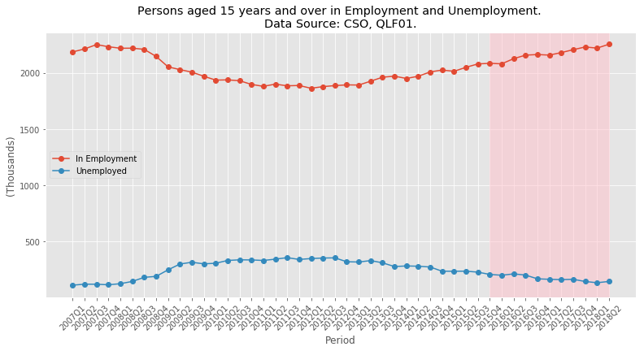Between Q1 2007 and Q1 2012 the total number of people unemployed in Ireland more than tripled from 115,000 to 351,800, with the unemployment rate increasing from 5% to 15.8% in the same period. Within the same timeframe, male unemployment increased from 4.9% to 18.1% and female unemployment increased from 5% to 13.1%. Figure 1 gives an illustration of the Irish economy in the crisis and post-crisis period, with the period in which JobPath operated shaded in red.

Figure 1

Following the initial onset of the economic crisis, widespread job losses led to an increase in short-term unemployment. This temporarily reduced the share of overall unemployment accounted for by those who are long-term unemployed (unemployed for one year or more). However, from mid-2009 onwards, long-term unemployment began to steadily increase its share of total unemployment, accounting for 60.6% in 2012 (Eurostat, 2018c).

The rate of long-term unemployment, or the number of individuals unemployed for one year or more as a percentage of the total labour force (aged 15-74), increased consistently from the onset of the crisis and reached a peak of 9.8% in Q1 2012. The crisis saw long-term unemployment increase for both men and women. In Q1 2007, long-term unemployment rates of men and women stood at 1.6% and 1% respectively, dramatically increasing to 12.3% and 6.7% by Q1 2012. Since then, male and female long-term unemployment have been on a generally downward trend, reaching 2.26% and 1.78% respectively in Q2 of this year.

## Methodology

There are a number of methodological challenges in designing an evaluation of JobPath.

1. All jobseekers may eventually be referred to a JobPath provider, which rules out a straightforward comparison between those referred to JobPath and those not referred. Furthermore, the key outcome variable (jobseeker labour market status) and a jobseeker’s referral status (whether or not they took part in JobPath) are both functions of the potential unemployment duration. At the same time, the referral process means a jobseeker can enter JobPath at any point beyond 12 months in an unemployment episode.
2. The measured effect of JobPath is contingent on the time when referral occurred and the time since referral. For this reason, the evaluation will measure who does better – jobseekers referred soon after becoming eligible or jobseekers referred to JobPath long after passing the eligibility threshold.

To address these challenges, DEASP and the OECD have developed a new modelling framework, which uses sophisticated modelling techniques (including cluster analysis), and improved outcome measurements to give us a comprehensive picture of how JobPath has worked for people.

This evaluation represents a major step forward in our ability to evaluate the effectiveness of our labour market programmes. Working with the OECD has ensured the evaluation has been conducted according to international best practices.

Moreover, this modelling framework is reusable, so that it will enable us to analyse a range of programmes in a high-quality and consistent way.

In brief, the implementation of cluster analysis to aid the evaluation of JobPath is as follows:

* At the beginning of each quarter, create a set of clusters from the Live Register population based on personal and labour market characteristics (such as age, sex, location, family structure, previous occupation, previous earnings) and employment, welfare and training history up to that point in time (duration of unemployment, any episodes of casual employment, participation in activation to date).
* Each cluster reflects a broad similarity among its members at that point in time. Membership of a given cluster will evolve over time, as individuals who remain unemployed become longer unemployed; those who have increased their skills in the interim become part of a more skilled group etc.
* For each cluster at each point in time we can generate outcomes that become richer over time as more data become available. In the immediate term, we can report on Live Register and activation/training status. In the medium term, we can report on employment status in a given year and, over a longer time frame, duration in employment and earnings levels.
* We can compare those who have started JobPath with those who, in each quarter, were eligible and observed in that quarter (still on the Live Register at quarter end or had commenced JobPath by quarter end).
* The clustering analysis approach will allow an estimate of the impact of JobPath for distinct cohorts (i.e. separate estimates for clusters with a greater share of long-term unemployed people in the 40-50 age group or those with a particular sectoral background).

The analysis begins by observing the eligible jobseekers across the quarter and dividing them into those who were eligible but did not start JobPath or exit the Live Register, and those who started JobPath in Q1 2016. The pool of eligible people are tracked across subsequent quarters into those who start JobPath later ( in Q2, Q3, Q4 etc.) and the diminishing pool of people who are eligible but do not start and do not exit the Live Register.

## Description of clusters

The description of clusters is covered in detail in the full paper. The table at the end of this note outlines the broad characteristics of each cluster.

* Cluster 0 can be classified as young individuals with high weeks of previous employment, short spells of unemployment, and high numbers of people previously in professional occupations.
* Cluster 1 has a majority of jobseekers between 30 and 40 years of age, and is characterised by short-term unemployment, moving out of the Live Register quickest in comparison to other clusters.
* Cluster 2 can be classified as the longest unemployed individuals from the widest range of ages, and the cluster with the highest share of JobPath eligible jobseekers.
* Cluster 3 is the youngest cohort, and includes individuals on casual jobseeker claims with short spells of unemployment durations.
* Cluster 4 contains individuals from a range of ages who are in and out of the labour market, with multiple spells of unemployment and low median weeks of insurable employment.
* Cluster 5 has a mostly older population who were previously in higher rank occupations, with little or no sign of labour market attachment and low median weeks of insurable employment.
* Cluster 6 has individuals on both ends of the age spectrum, but more of these individuals are older and previously self-employed, with the second highest median unemployment duration.

Figure 2 – Cluster size over time

## JobPath eligibility by cluster

The figure below illustrates how eligibility for being referred to JobPath differs by cluster. In other words, each cluster’s share of the Live Register population is not the same as its share of the eligible population for JobPath. This makes sense because the clusters bring together people with similar labour market histories and personal characteristics, so that people with longer unemployment durations are more likely to be found in some clusters than others.

In turn, this clustering ensures that our outcome measures are not biased by the fact that JobPath starters in Q1 2016 were more distant from the labour market than those who were eligible but did not start.

That is, jobseekers *within each cluster* have similar labour market histories, particularly once non-JobPath-eligible people are excluded.

Figure 3 –JobPath eligibility by cluster, Q1 2016

## 

### Estimation of JobPath Effects

As noted above, among the methodological challenges in evaluating JobPath is the inability to conduct a straightforward comparison between those referred to JobPath and those who are not referred. In addition, for any new employment service, the referral process takes time to stabilise. In the case of JobPath, a stratified sample of jobseekers were referred from a pool of eligible population selected based on claim status and duration of unemployment.

Typically, a counterfactual evaluation includes matching those who received a service with those who did not, which allows an estimation of the impact of the service by comparing the outcomes of both groups. However, the treatment group that receives a service may not be identical to the control group which did not.

From initial analysis of JobPath, it became evident that not all of the control group are suitable to match to members of the treatment group. Specifically, the earnings of the control group in the years before JobPath is rolled out (2013-2015) are higher than those of the treatment group. Furthermore, initial analysis shows that those who received the JobPath service increased their earnings by more (in absolute terms) but that they had lower earnings in previous years.

Based on the assumption that earnings are a proxy for a range of other labour market characteristics, it is advisable to correct for this disparity between the treatment and control groups. In the event that past earnings do not capture the full extent of latent labour market success, the mean amount received in social benefits (all payments made by DEASP), and total duration of unemployment in the past five years are also used to align the treatment and control groups.

Based on the information above, all open claims on the Live Register in Q1 2016 are sorted into treatment and control groups are aligned by taking the following steps:

* Removing those over the age of 60 (accounting for operational activation practices)
* Removing those with durations of unemployment under 300 days to capture only those approaching long-term unemployment
* Removing those who have already received the JobPath service
* Generating centile rankings based on:
  + mean earnings in the 2013-2015
  + mean social welfare payments 2013-2015
  + duration of unemployment in the past five years

At this point, each of the treatment observations has a ranking based on previous earnings, social welfare payments and unemployment duration. Each control observation is matched to this by selecting only the controls where earnings, payments and duration values are within the range of treatment values.  
  
This approach gives an equal number of treatment observations in each centile whereas the number of control observations varies. Then, the control observations are weighted to align with the number of treatment observations. This methodology aligns the treatment and control groups based on histories of earnings and social welfare receipt, which allows for a comparable measurement of outcomes. This allows us to estimate the effect of JobPath.

## Initial results

Our initial outcome measure for the population clustered at the beginning of Q1 2016 is how much 2017 earnings from employment, and total income, change compared to mean earnings over 2013-2015 within each cluster, for JobPath starters (T1) and those eligible but who did not start (C1).

### Weighting of control group cases

We’ve weighted the C1 group results to ensure that there is no bias in earnings or total income history. The figures below show that mean previous earnings are not significantly different for any cluster, except cluster 3 (marginally), after weighting is applied.

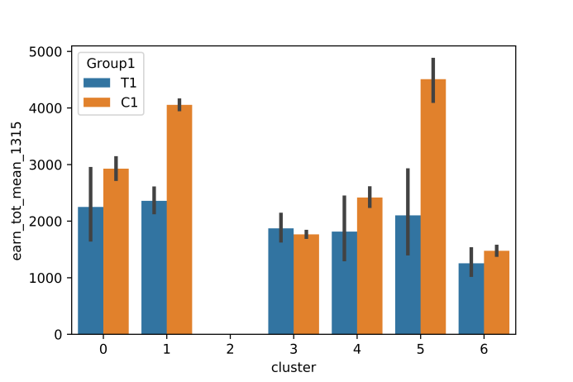

Figure - Previous earnings (pre-weighting)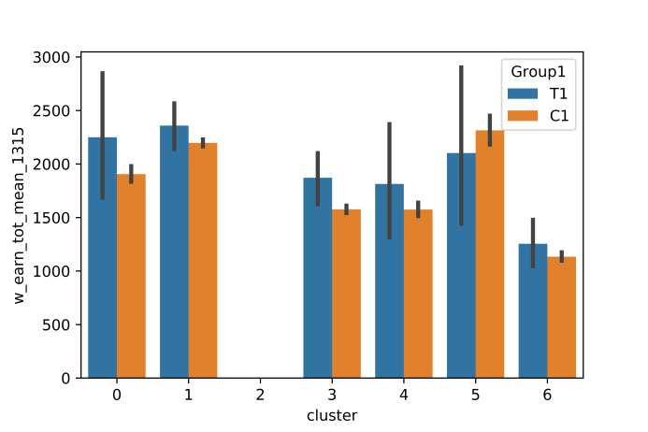

Figure - Previous earnings (after weighting)

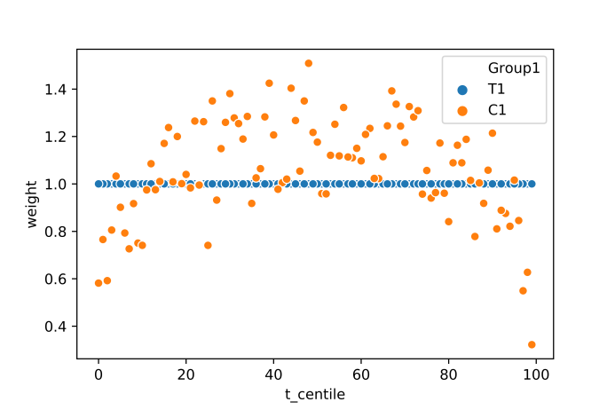

Figure - Weighting factor applied, by centile

Globally, there is a consistent positive effect for people who started JobPath in Q1 2016. However, the partition of the entire Live Register population into clusters shows how JobPath works differently for different clusters.

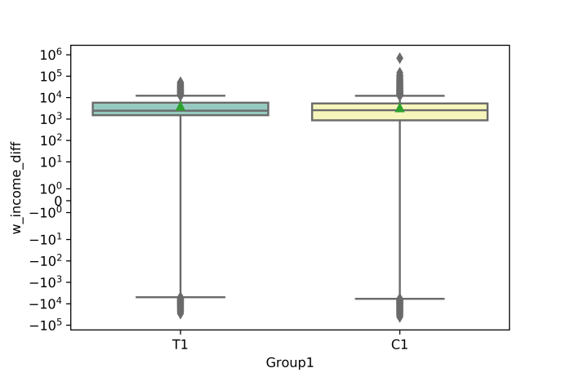

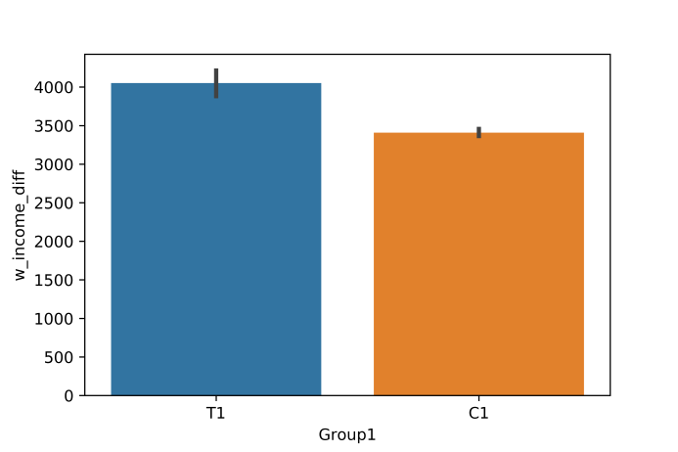

Figure - Change in income for JobPath starters (T1) and weighted eligible non-starters (C1), with 95% confidence intervals

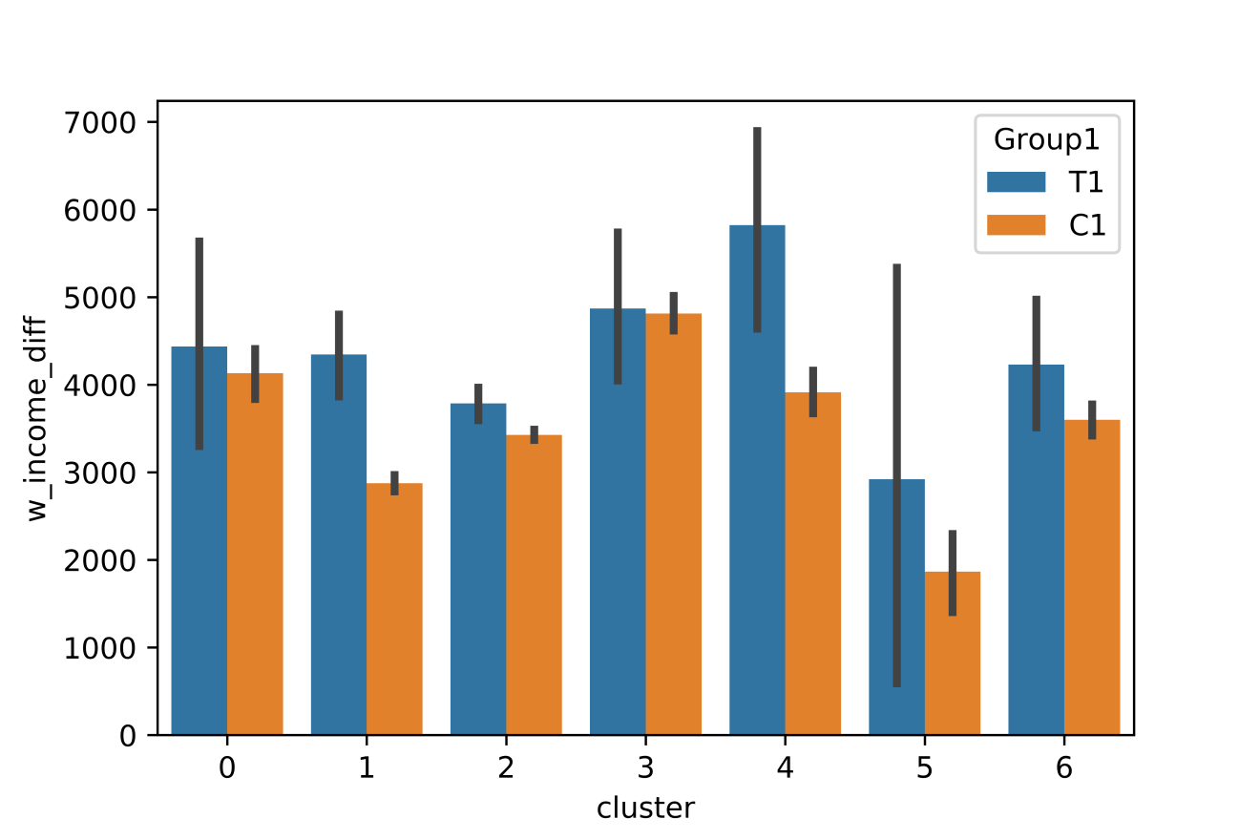

Figure - Change in total income (employment and Social Welfare) by cluster, for JobPath starters (T1) and weighted eligible non-starters (C1), with confidence intervals

## Description of clusters

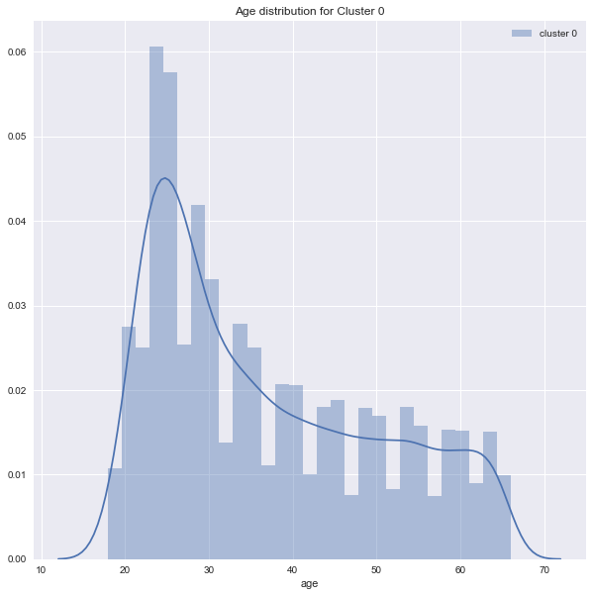**Cluster 0**

Figure 9

**Cluster 0 can be classified as young individuals with high weeks of previous employment, short spells of unemployment, and high numbers of people previously in professional occupations.** This cluster has a population of 16,061 and 39% of this cluster is eligible for JobPath. The majority of individuals in this cluster are under the age of 30. Unlike the other clusters, which are male dominated; this cluster broadly has the same ratio of men (53%) to woman (47%). Following Cluster 1, this group has the second highest number of weeks of insurable employment. This cluster’s labour market attachment is above average, with 97% having been in employment at some point in the five preceding calendar years. This cluster has median unemployment duration of 200 days. This cluster is above average in the share of jobseekers reporting previous professional occupations.

Share of Cluster 0 eligible for JobPath: 39%

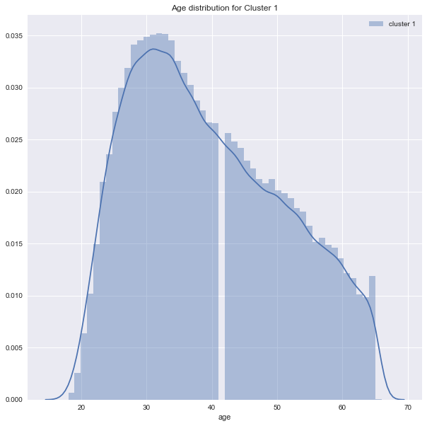**Cluster 1**

**Cluster 1 has a majority of jobseekers between 30 and 40 years of age, and is characterised by short-term unemployment, moving out of the Live Register quickest in comparison to other clusters.** This cluster has a population of 121,932 and 45% of this cluster are eligible for JobPath. The majority of this cluster is between 30 and 40 years of age. Similar to cluster 0, this cluster differs from the majority of clusters that are male dominated, with a broadly similar share of men (56%) to women (44%). Cluster 1 has strong labour market attachment, with an above average share (95%) of jobseekers that were previously in employment in the preceding calendar years. In this cluster, those with previous professional occupations have a significant decrease of unemployment duration compared to other clusters. The median unemployment duration for this cluster is 242 days. It has an above average share of jobseekers whose previous occupation was in clerical and secretarial positions.

Figure 10

Share of Cluster 1 eligible for JobPath: 45%

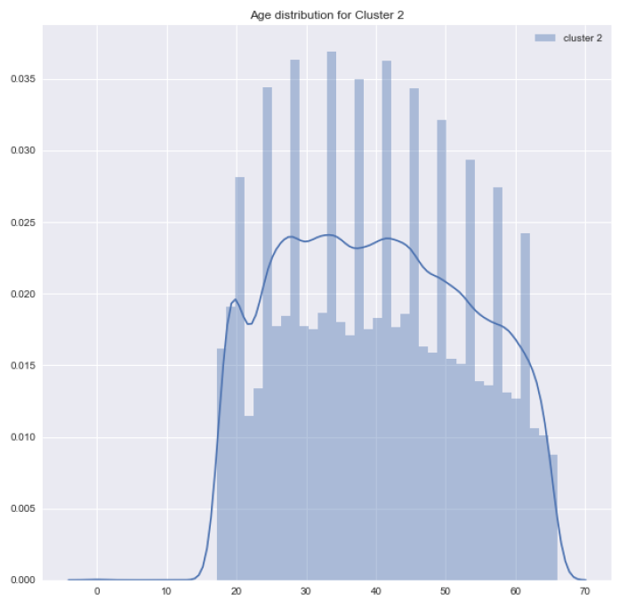**Cluster 2**

**Cluster 2 can be classified as the longest unemployed individuals from the widest range of ages, and the cluster with the highest share of JobPath eligible jobseekers**. With a population of 97, 946, this cluster makes up one third of the total cluster population and has a JobPath eligibility rate of 82%. Cluster 2 is the farthest from the labour market, with only 56% having had an episode of employment in the past five years. This figure is below the average of 80% for other clusters. This weak labour market attachment is reflected in the cluster’s median earnings of 0 in the last 3 years. Furthermore, this cluster has the longest median unemployment duration of 1, 534 days. This cluster has a concentration of those whose previous occupation was plant and machine operatives (14%) and the lowest share of those who were previously in managerial or professional occupations (7%). Overall, this cluster includes the longest unemployed individuals, who are furthest from the labour market.

Figure 11

Share of Cluster 2 eligible for JobPath: 82%

**Cluster 3**

**Cluster 3 is the youngest cohort, and includes individuals on casual jobseeker claims with short spells of unemployment durations.** This cluster has a population of 30, 637 individuals, 33% of which are eligible for JobPath. 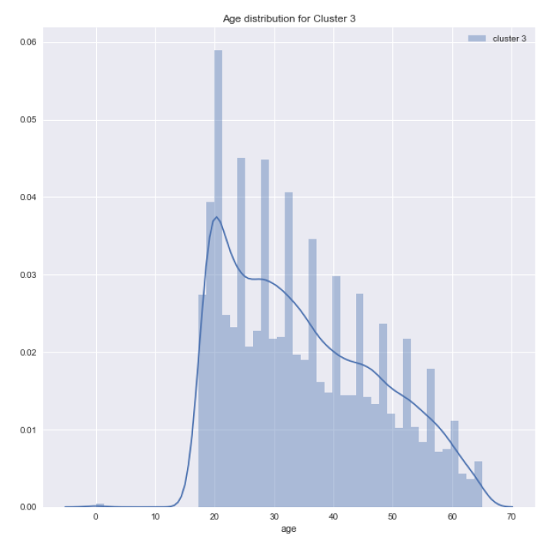As the youngest cohort, they have earnings only in the previous calendar years but have the second highest median number of weeks of insurable employment. Cluster 3 has the lowest median duration of unemployment with 175 days. This cluster has the shortest duration of unemployment episodes. This cluster has a large share of Craft and Related Occupations (31%) but a low share of managerial and professional occupations (11%), which can be partly attributed to the young age of jobseekers in this cohort. This cluster includes jobseekers on casual jobseeker claims, meaning they are in part-time work of fewer than four days and receive an unemployment payment in respect of the days not worked. Generally, this cluster can be categorized as young, casual claimants with short unemployment durations.

Figure 12

Share of Cluster 3 eligible for JobPath: 33%

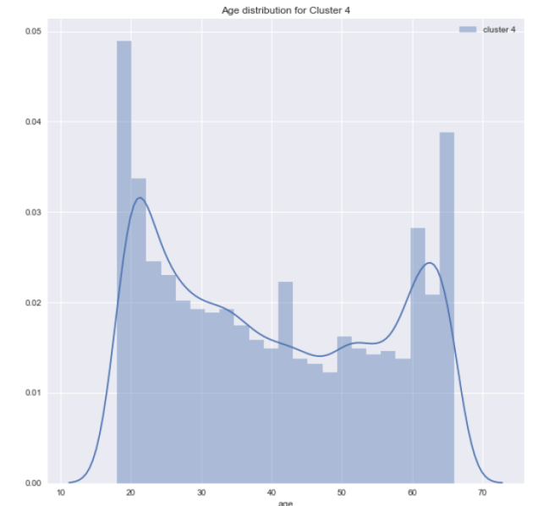**Cluster 4**

**Cluster 4 contains individuals from a range of ages who are in and out of the labour market, with multiple spells of unemployment and low median weeks of insurable employment.** This cluster has a population of 18,258 jobseekers, 39% of which are eligible for JobPath. Cluster 4 contains people at both ends of the age spectrum, with a mix of old and young individuals but more young. In this cluster, jobseekers tend to have low median weeks of insurable employment. This cluster has median unemployment duration of 221 days. Within this cluster, 82% of individuals previously had higher ranked occupations, such as Craft and Related Occupations and Clerical and Secretarial Occupations. Generally, these individual are in and out of the labour market, with little to no sign of labour market attachment.

Figure 13

Share of Cluster 4 eligible for JobPath: 39%

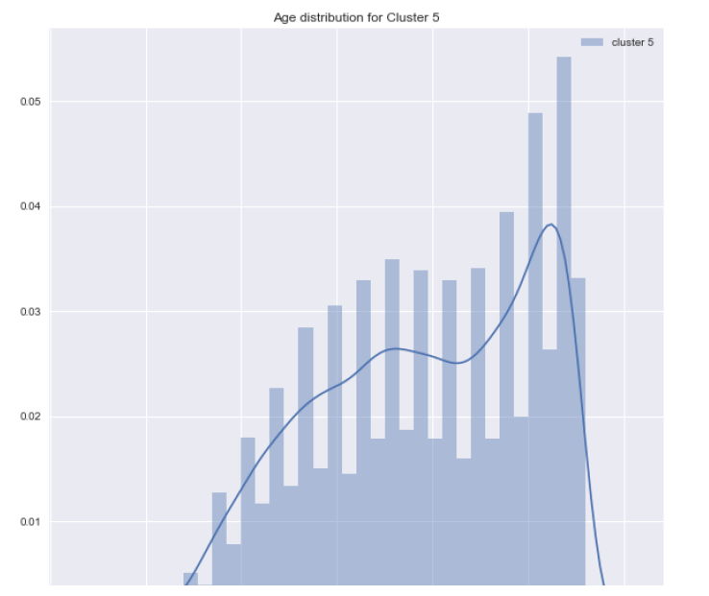**Cluster 5**

**Cluster 5 has a mostly older population who were previously in higher rank occupations, with little or no sign of labour market attachment and low median weeks of insurable employment.** While cluster 5 is the smallest cluster, with a population of 12, 789, over half of the cluster population (51%) is eligible for JobPath. This cluster contains mostly older individuals and makes up 4% of the total population. Individuals in this cluster have shown little to no sign of labour market attachment, with low median weeks of insurable employment. The median unemployment duration for this cluster is 305 days. Within this cluster, 88% of individuals previously held higher rank occupations, with the majority in Craft and Related Occupations. Furthermore, this cluster has shown the least age variation of previous occupations. In sum, this cluster can be classified as individuals who will likely retire in the near future.

Figure 14

Share of Cluster 5 eligible for JobPath: 51%

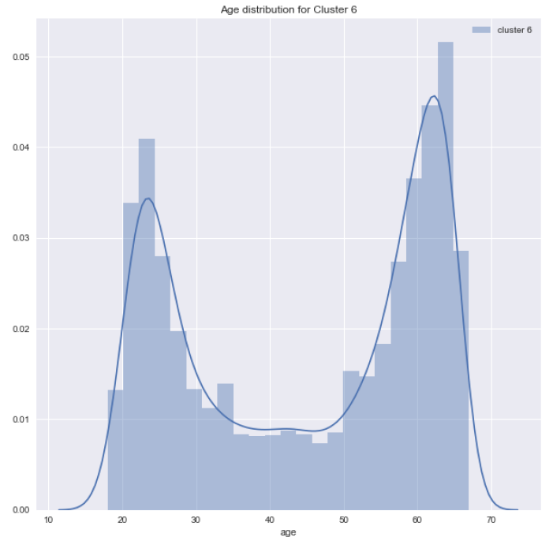 **Cluster 6**

**Cluster 6 has individuals on both ends of the age spectrum, but more of these individuals are older and previously self-employed, with the second highest median unemployment duration.** This cluster has a population of 29, 408 individuals, and the second highest share (67%) of JobPath eligible individuals. In terms of employment history, this cluster has low median weeks of insurable employment and there is weak labour market attachment. This cluster has the second highest median unemployment duration of 661 days. Among those who were employed within this cluster, 85% held higher rank occupations and this cluster has a large share of previously self-employed individuals.

Figure 15

Share of Cluster 6 eligible for JobPath: 67%